**ECE 763 PROJECT 1**

**Shubham Miglani**

**Data Preprocessing:**

1. FDDB dataset was used. (<http://vis-www.cs.umass.edu/fddb/>)
2. There are 10 text files in the dataset for annotation and file name data. 9 text files were combined for training data and the rest one was for test data.
3. The elliptical coordinates in the annotation file provided in the dataset were converted to rectangular ones. Only images with number of faces as 1 were taken.
4. After getting the rectangular coordinates, all the data inside the rectangle was cropped and saved separately.
5. For non-face data, the image area not belonging to the face and an area of (60,60) was cropped and saved separately.
6. Then all the images are resized to 20,20 and saved in npy format for faster loading.
7. PCA is used for Model 1, Model 2, Model 3 as the feature space is huge. Also, the data is standardized with mean 0 and variance 1.
8. All the training and data loading was done on google Colab and using google drive. The paths must be changed correspondingly if running on a local machine

**Model 1: Simple Gaussian**

Mean of face:

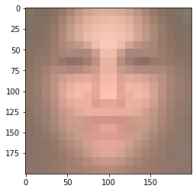

Mean of non face:

Covariance of face:

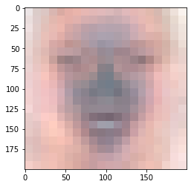

Covariance of nonface:

False Positive Rate: 0.44

False Negative Rate: 0.41

Miss Classification Rate: 0.425

ROC Curve:

**Model 2: Mixture of Gaussian**

Number of gaussians was chosen as 3. All the plots are for the 1st gaussian. PCA is used with size 30.

Mean of face:

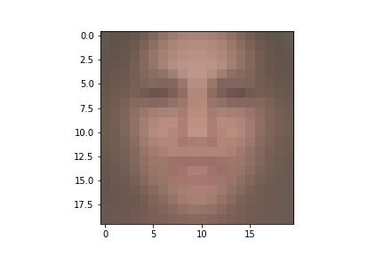

Mean of non face:

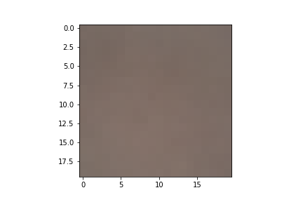

The diagonal Covariance matrix is plotted as shown

Covariance face:

Covariance non face:

False Positive Rate: 0.3

False Negative Rate: 0.36

Miss Classification Rate: 0.33

ROC curve:

**Model 3: t-distribution**

Mean of face:

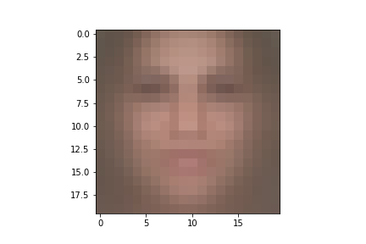

Mean of face:

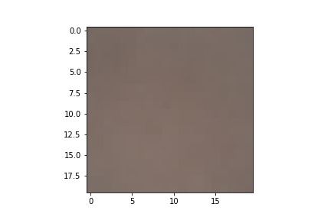

Covariance of face:

Covariance of nonface:

False Positive Rate: 0.36  
False Negative Rate: 0.52  
Miss Classification Rate: 0.44  
ROC:

**Model 4: Factor analyzer**

Mean of face:

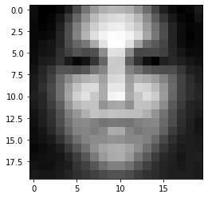

Mean of nonface:

Covariance of face:

Covariance of nonface:

False Positive Rate: 0.46

False Negative Rate: 0.24

Miss Classification Rate: 0.35ROC Curve:

References:

1. <http://www.computervisionmodels.com/>
2. <https://github.com/NazneenKotwal/CV_Face_Image_Classification_Python>
3. <https://github.com/ankanbansal/fddb-for-yolo/blob/master/convertEllipseToRect.py>